Analytic View is in the form of Star schema, wherein we join one Fact table to multiple Dimension tables. Analytic views use real power of SAP HANA to perform complex calculations and aggregate functions by joining tables in form of star schema and by executing Star schema queries.

Characteristics of Analytic View

Following are the properties of SAP HANA Analytic View −

* Analytic Views are used to perform complex calculations and Aggregate functions like Sum, Count, Min, Max, Etc.
* Analytic Views are designed to run Start schema queries.
* Each Analytic View has one Fact table surrounded by multiple dimension tables. Fact table contains primary key for each Dim table and measures.
* Analytic Views are similar to Info Objects and Info sets of SAP BW.

1. Create a new Analytical view.

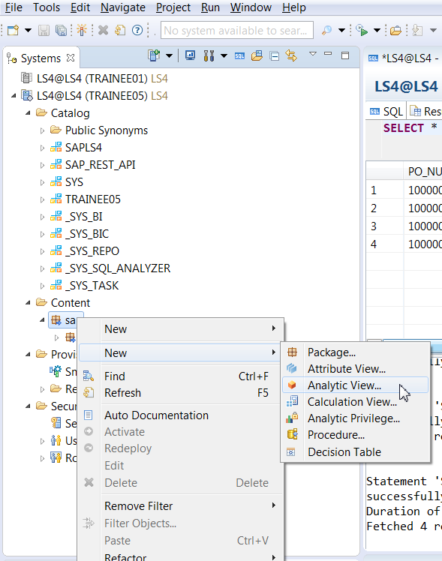

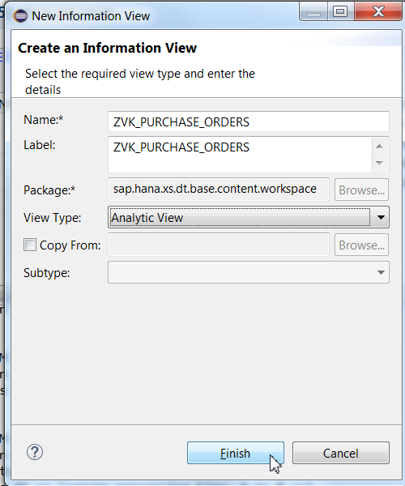

1. Select "AT_PRODUCT" Attribute view from Modelling package.
2. Drag and Drop Attribute View in Star Join Node.

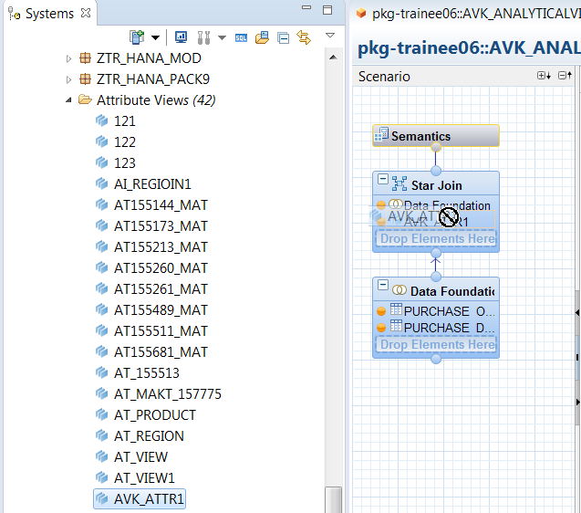

1. Click on data foundation node. Table added in data foundation node will display in Detail section.
2. Join Table "PURCHASE_ORDER" To Table "PURCHASE_DETAIL" ON "PO_NUMBER" Field.
3. Enter Join type and Cardinality.

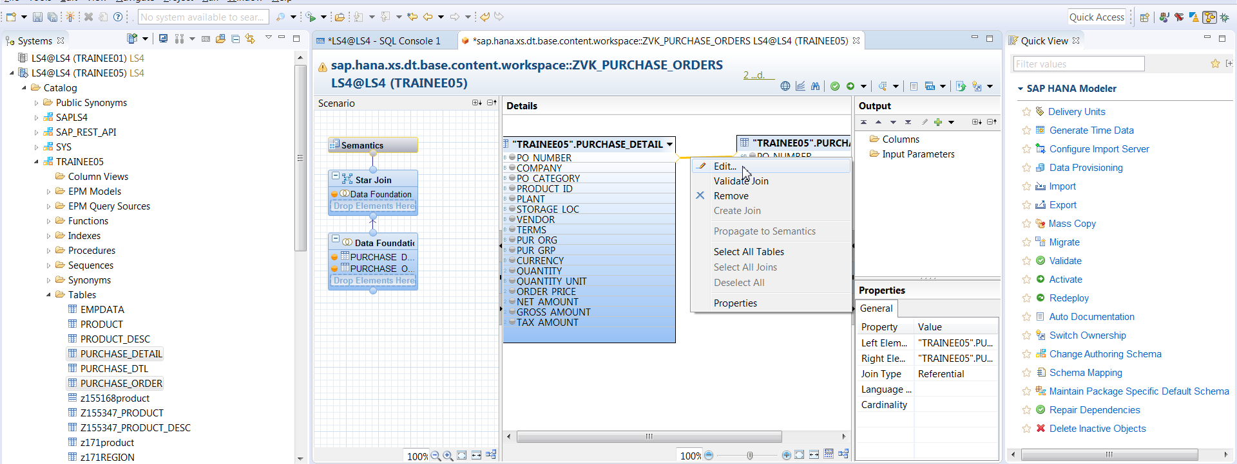

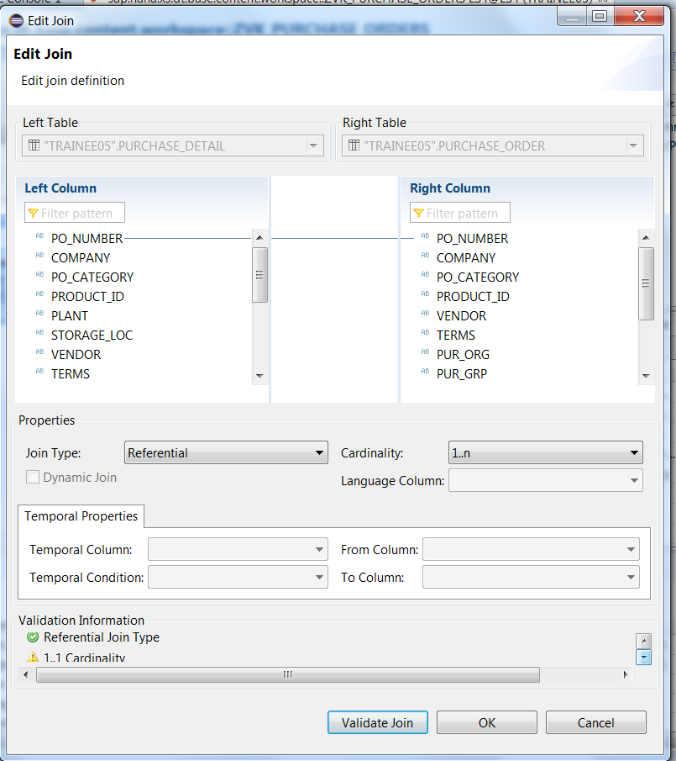

Select PO_NUMBER, COMPANY, PO_CATEGORY, PRODUCT_ID, PLANT, STORAGE_LOC from "PURCHASE_DETAIL" Table.

Select CURRENCY Column From "PURCHASE_DETAIL" Table.

Select GROSS_AMOUNT, TAX_AMOUNT.

Select PO_STATUS, CREATED_BY, CREATED_AT Column From "PURCHASE_HEADER" Table.

Ctrl+Click to select columns from both tables.

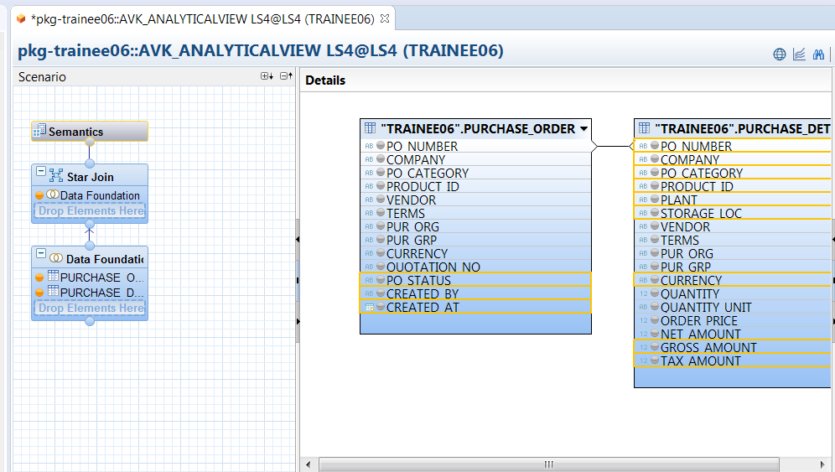

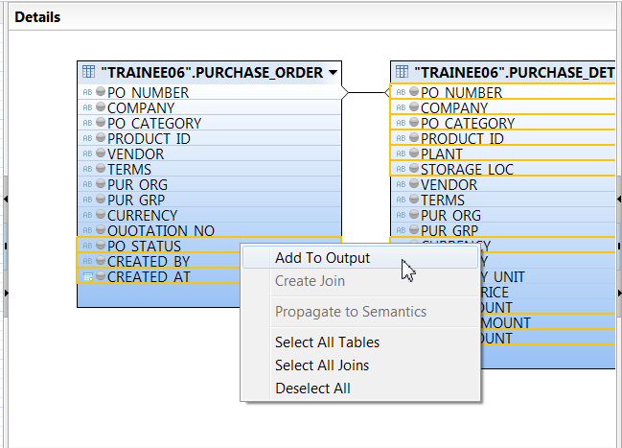

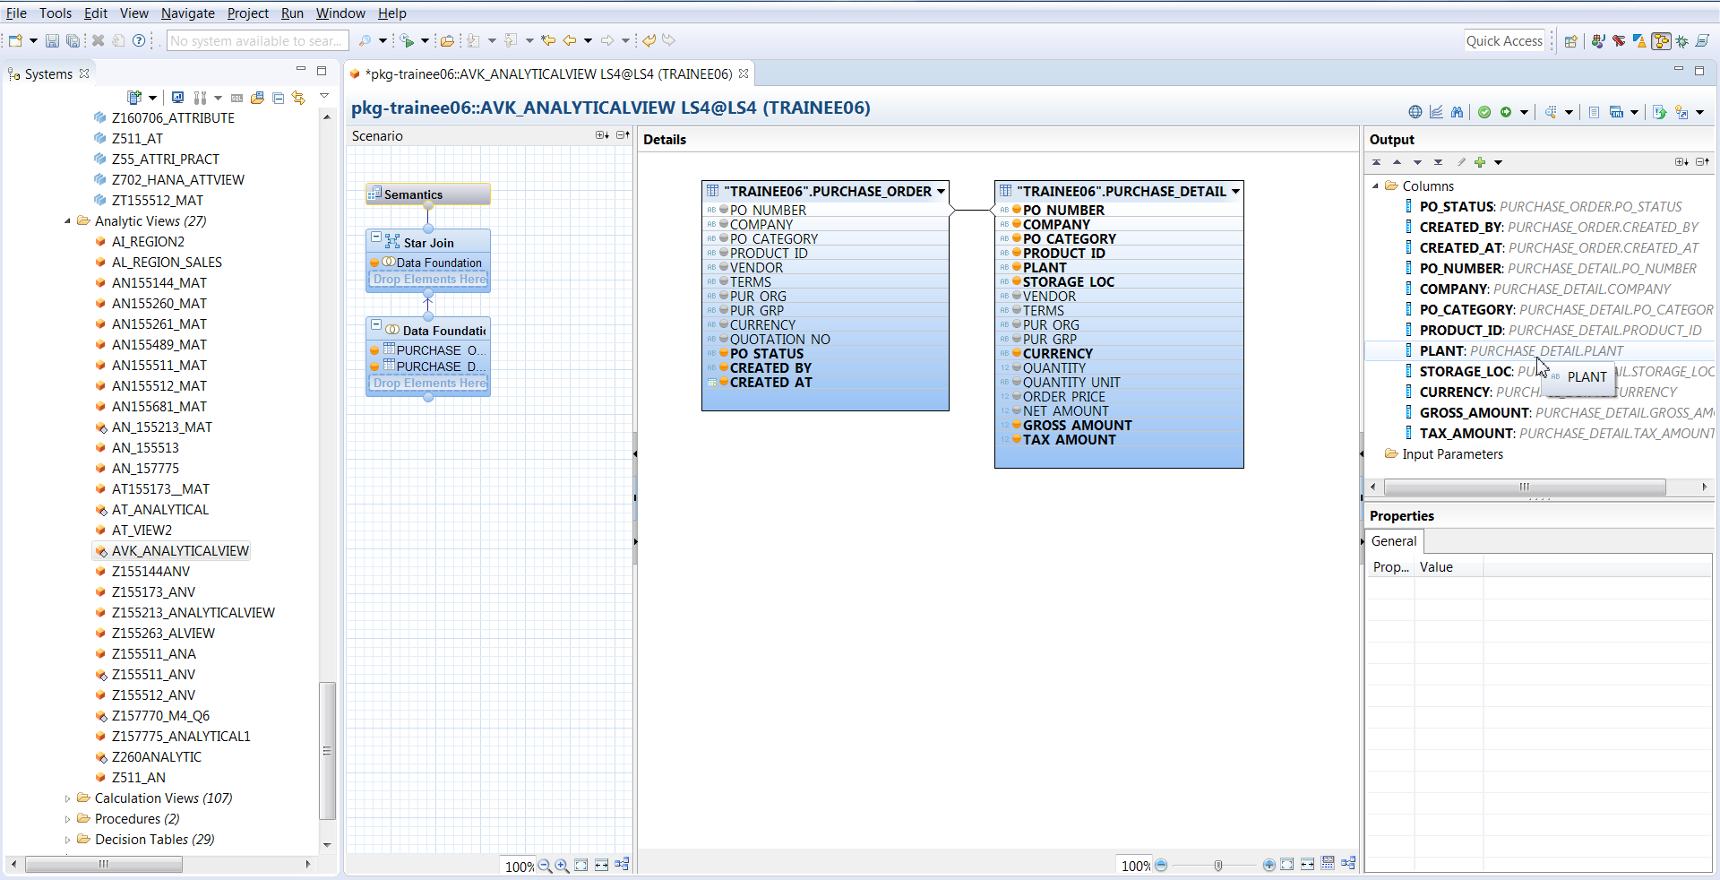

Add Net Amount field also.

Click on Star join Node in semantic pane, as below –

Attribute view and fact table will be displayed in the detail pane. Now we Join attribute view to fact table as below -

Join Attribute View with Data Foundation on "PRODUCT_ID" Column.

